

**İZMİR INSTITUTE OF TECHNOLOGY**

**ELECTRICAL AND ELECTRONICS ENGINEERING DEPARTMENT**

**EE451 Communication Systems II Laboratory Project Final Report**

**QPSK vs π/4-DQPSK**

**Project Members :**

# Eren HEPGÜLER 280206068

Dilde GÜLTEKİN 260206009

# Ferhat BÖCEK 260206070

**Date :** 22.12.2022

**Quadrature Phase-Shift Keying**

**(QPSK)**

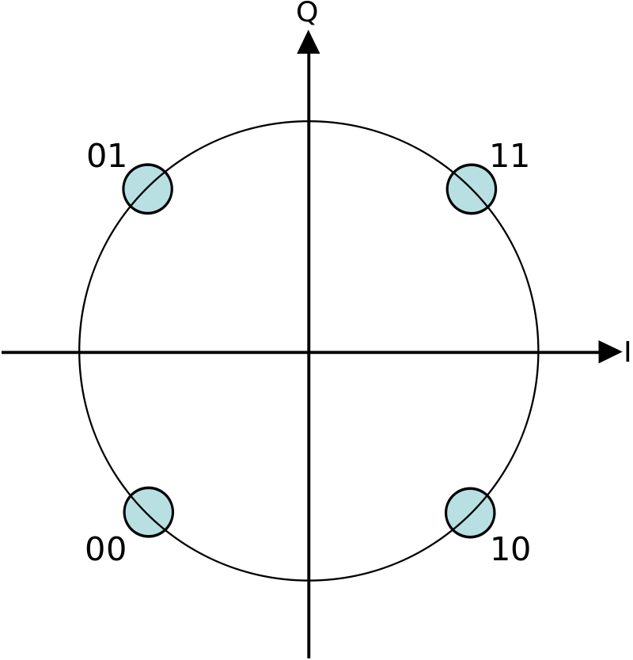

**Figure 1. Constellation diagram for QPSK with** [**Gray coding**](https://en.wikipedia.org/wiki/Gray_coding)**. Each adjacent symbol only differs by one bit**

Quadrature phase shift keying (QPSK) is a type of digital modulation that is used to transmit information over a communication channel. It is a type of phase shift keying (PSK) in which the phase of the carrier signal is shifted by 0, 90, 180, or 270 degrees in response to four different digital input symbols. In QPSK, two bits of information are transmitted at a time, using four different phase shifts to represent the four possible combinations of the two bits. For example, if the two bits are 00, the phase of the carrier signal is not shifted; if the two bits are 01, the phase is shifted by 90 degrees; if the two bits are 10, the phase is shifted by 180 degrees; and if the two bits are 11, the phase is shifted by 270 degrees. QPSK is used in many different types of communication systems, including satellite communications, digital television, and mobile phone systems. It is a popular choice for these systems because it has a relatively low error rate and can be implemented using relatively simple hardware.

In QPSK, the phase of the carrier signal is changed based on the two input bits, but the amplitude of the signal remains constant. This means that the signal is only carrying information about the phase of the carrier, not the amplitude. To transmit a QPSK signal, the sender first encodes the information to be transmitted as a series of digital bits. The bits are then divided into pairs, and each pair is used to determine the phase shift that should be applied to the carrier signal. The carrier signal is then modulated with the phase shifts and transmitted over the communication channel. At the receiver end, the QPSK signal is demodulated to extract the original information. This is done by measuring the phase shifts of the received signal and comparing them to the known phase shifts used by the sender. The phase shifts are then used to decode the original information from the digital bits. QPSK is a popular choice for digital communication systems because it has a relatively low error rate and can be implemented using relatively simple hardware. It is also relatively resistant to noise and interference, which makes it well-suited for use in noisy or crowded communication environments.

**π/4-Differential Quadrature Phase-Shift Keying**

**(DQPSK)**

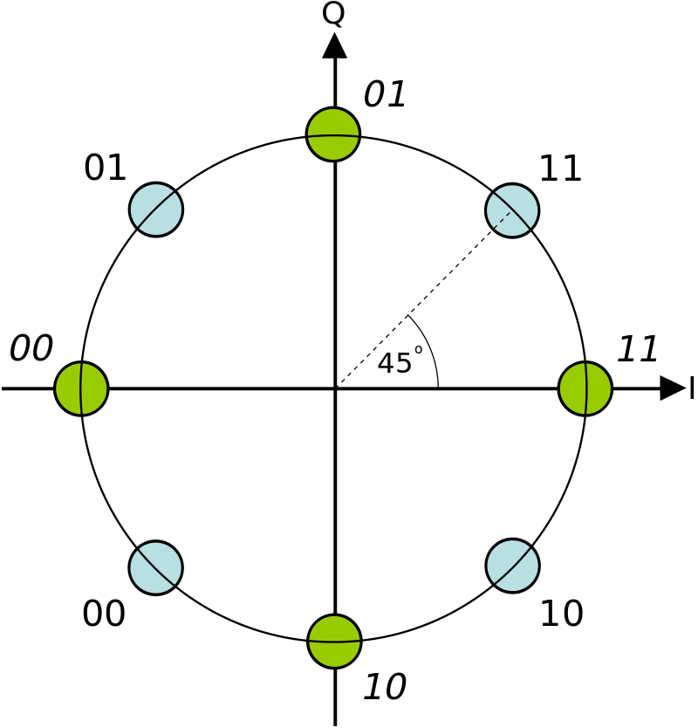

**Figure 2. Dual constellation diagram for π/4-QPSK. This shows the two separate constellations with identical Gray coding but rotated by 45° with respect to each other.**

Differential quadrature phase shift keying (DQPSK) is a type of digital modulation that is similar to quadrature phase shift keying (QPSK), but with one key difference: in DQPSK, the phase of the carrier signal is not directly determined by the input data bits, but rather by the difference between the current and previous input data bits. In DQPSK, the input data bits are still divided into pairs and used to determine the phase shift that should be applied to the carrier signal. However, instead of directly determining the phase shift, the input data bits are used to calculate the difference between the current and previous phase shifts. This difference is then used to determine the phase shift for the current symbol. For example, if the previous phase shift was 0 degrees and the current input data bits are 01, the difference between the previous and current phase shifts would be 90 degrees, so the current phase shift would be 90 degrees. If the previous phase shift was 90 degrees and the current input data bits are 01, the difference would be 0 degrees, so the current phase shift would be 180 degrees. DQPSK is used in many different types of communication systems, including satellite communications and mobile phone systems. It is a popular choice for these systems because it has a relatively low error rate and can be implemented using relatively simple hardware. It is also relatively resistant to noise and interference, which makes it well-suited for use in noisy or crowded communication environments.

One advantage of DQPSK over QPSK is that it is more resistant to certain types of noise and interference, such as phase jitter. In QPSK, a small change in the phase of the carrier signal can result in a significant change in the transmitted data, which can lead to errors. In DQPSK, the phase shift is determined by the difference between the current and previous phase shifts, rather than the absolute phase shift, which makes it less sensitive to phase jitter. Another advantage of DQPSK is that it allows for higher data rates than QPSK, because it transmits two bits of information per symbol, rather than just one. This is because the phase shift is determined by the difference between the current and previous input data bits, which means that two bits of information are transmitted with each symbol. To transmit a DQPSK signal, the sender first encodes the information to be transmitted as a series of digital bits. The bits are then divided into pairs, and the difference between the current and previous phase shifts is calculated based on the current and previous input data bits. The carrier signal is then modulated with the phase shifts and transmitted over the communication channel. At the receiver end, the DQPSK signal is demodulated to extract the original information. This is done by measuring the phase shifts of the received signal and comparing them to the known phase shifts used by the sender. The phase shifts are then used to decode the original information from the digital bits. Overall, DQPSK is a powerful digital modulation technique that is widely used in a variety of communication systems. It has a relatively low error rate, can be implemented using relatively simple hardware, and is relatively resistant to noise and interference, which makes it well-suited for use in a variety of communication environments.

### Implementation (QPSK - DQPSK)

**QPSK Implementation**

Writing the symbols in the constellation diagram in terms of the sine and cosine waves used to transmit them:



The four phases π/4, 3π/4, 5π/4 and 7π/4 as needed.

This results in a two-dimensional signal space with unit basis functions

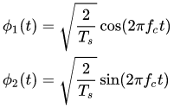

The first basis function is intended to be used as the in-phase component of the signal. The second basis function is used as the quaternary component of the signal. For this reason, the constellation diagram will be represented by 4 points in the signal space.



Since the total power is divided equally in the two carriers, the 1/2 anchors are multiplied by Es in the expression.

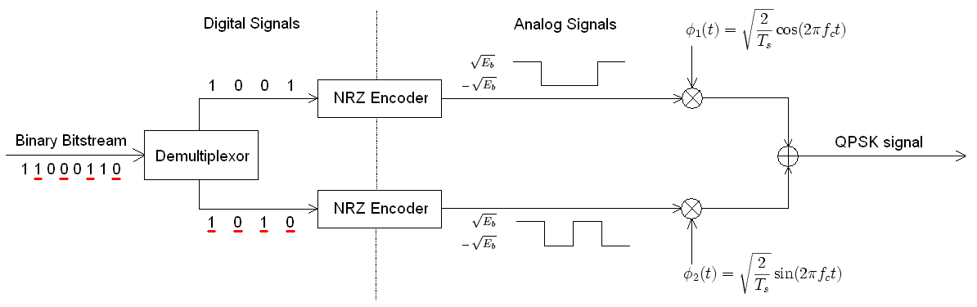

**Transmitter Structure for QPSK**

**Here you can see the transmitter circuit diagram of the QPSK modulation structure. First of all, binary data are separated by co-phased and quaternary components. These data are then modulated on two orthogonal basis functions to be modulated. Two sinusoids are used in this modulation type. First, the two signals are superimposed and the QPSK signal is generated. Then, although encoders can be placed first, they are placed later in the diagram in order to focus and understand the conceptual differences between digital and analog signals.**

**A conceptual transmitter structure for Quadrature Phase Shift Keying (QPSK) can be explained as follows:**

**1) Data generation: The first step in the transmitter is the generation of the data to be transmitted. This can be achieved by using a data source such as a computer or a sensor.**

**2) Data encoding: The data is then encoded using a suitable coding scheme to improve the reliability of the transmission. This can be done using techniques such as error correction coding or forward error correction.**

**3) Modulation: The encoded data is then modulated using QPSK. In QPSK, the phase of the carrier signal is changed based on the data being transmitted. This is achieved by dividing the data into two streams, each representing one of the two bits in a symbol. These two streams are then used to modulate the phase of the carrier signal in quadrature.**

**4) Upconversion: The modulated signal is then upconverted to the desired frequency band using a mixer and a local oscillator.**

**5) Power amplification: The upconverted signal is then amplified using a power amplifier to increase its strength.**

**6) Antenna: The amplified signal is then transmitted using an antenna.**

**This is a basic outline of the transmitter structure for QPSK. The actual implementation may vary depending on the specific requirements of the system.**

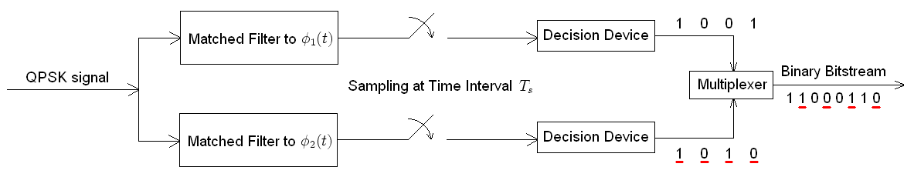

**Receiver structure for QPSK**

**In more detail, the receiver structure for QPSK involves several steps to recover the original data from the received signal.**

**Antenna: The received signal is captured by an antenna and passed through a low noise amplifier (LNA) to increase its strength. The LNA is an amplifier with a very low noise figure, which is a measure of the amount of noise that it adds to the signal. This is important because the received signal may be very weak, and any additional noise introduced by the amplifier could make it difficult to recover the original data.**

**Downconversion: The amplified signal is then downconverted to a lower frequency band using a mixer and a local oscillator. The mixer combines the received signal with a sinusoidal signal from the local oscillator to produce sum and difference frequencies. The difference frequency is typically in a lower frequency band than the original signal, and it can be filtered out using a bandpass filter. This process, known as downconversion, reduces the complexity of the following stages of the receiver.**

**Filtering: The downconverted signal is then passed through a bandpass filter to remove any unwanted frequencies and improve the signal-to-noise ratio (SNR). The SNR is a measure of the strength of the signal relative to the noise present in the signal. A higher SNR makes it easier to recover the original data.**

**Demodulation: The filtered signal is then demodulated to recover the original data. In QPSK, this is achieved by using a pair of mixers, a local oscillator, and a low pass filter. The mixers are used to multiply the received signal by the local oscillator signal, producing sum and difference frequencies. The low pass filter is used to remove the sum frequencies, leaving only the difference frequencies, which contain the data streams that were used to modulate the carrier signal in quadrature.**

**Data decoding: The demodulated data is then decoded using the same coding scheme that was used at the transmitter to improve the reliability of the transmission. This can involve techniques such as error correction coding or forward error correction, which allow the receiver to detect and correct errors that may have occurred during the transmission.**

**Data processing: The decoded data is then passed to a data sink, such as a computer or a display, for further processing or display.**

**Probability of Error**

**We can view QPSK modulation as a quadrature modulation type, but in fact it is easier to view it as two independently modulated quadratic carriers. In this way, even or odd bits will be used to modulate the in-phase component of the carrier, while odd or even bits will be used to modulate the quadrature component of the carrier.**

**As a result, the probability of bit-error for QPSK**



**The symbol error rate is given by:**

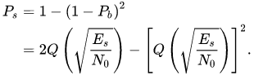

**If the** [**signal-to-noise ratio**](https://en.wikipedia.org/wiki/Signal-to-noise_ratio) **is high (as is necessary for practical QPSK systems) the probability of symbol error may be approximated:**



The following image shows a diagram of a modulated signal represented by an arbitrary binary data stream. Two carrier waves, one cosine wave and the other sine wave, are shown by signal-space analysis. Here, odd-numbered bits are assigned to the in-phase component and even-numbered bits are assigned to the quadrature component (the first bit is taken as 1).

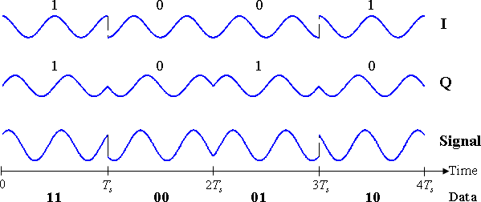

**Timing diagram for QPSK**

The binary data stream is shown beneath the time axis. The two signal components with their bit assignments are shown at the top, and the total combined signal at the bottom. Note the abrupt changes in phase at some of the bit-period boundaries.

The binary data that is conveyed by this waveform is: 11000110.

* The odd bits, highlighted here, contribute to the in-phase component: 11000110
* The even bits, highlighted here, contribute to the quadrature-phase component: 11000110

To briefly mention other factors that affect the probability of error in QPSK and DQPSK, it will enable us to understand the probability of error in this modulation type and other factors that determine this probability.

QPSK (Quadrature Phase Shift Keying) is a type of digital modulation in which two bits of information are transmitted at a time by shifting the phase of a carrier signal by one of four possible values: 0, 90, 180, or 270 degrees. The probability of error in QPSK depends on a number of factors, including the signal-to-noise ratio (SNR) of the channel, the level of interference present, and the distance between the transmitter and receiver.

In general, the probability of error in QPSK decreases as the SNR increases. This means that as the signal becomes stronger relative to the noise, the probability of an error occurring during the transmission of the data decreases. The probability of error also decreases as the distance between the transmitter and receiver decreases, because the signal has less distance to travel and is therefore less likely to be affected by noise or interference.

The probability of error in DQPSK depends on a number of factors, including the signal-to-noise ratio (SNR) of the channel, the level of interference present, and the distance between the transmitter and receiver. The SNR is a measure of the strength of the signal relative to the noise in the channel. A high SNR means that the signal is strong compared to the noise, while a low SNR means that the noise is strong relative to the signal. The probability of error in DQPSK tends to decrease as the SNR increases, because a stronger signal is less likely to be affected by noise or interference.

There are various ways to calculate the probability of error in QPSK, but one common method is to use the bit error rate (BER) formula. The BER is defined as the number of bits that are received incorrectly divided by the total number of bits transmitted. The BER can be expressed as a function of the SNR and the distance between the transmitter and receiver. For example, if the SNR is 10 dB and the distance between the transmitter and receiver is 1 kilometer, the BER might be on the order of 10^-5.

Interference is any extraneous signal that can disrupt the transmission of data. Interference can come from a variety of sources, including other communications systems, electrical equipment, and even natural phenomena such as lightning. The probability of error in QPSK can be increased by interference, because the presence of extraneous signals can cause the receiver to misinterpret the transmitted data.

The distance between the transmitter and receiver can also affect the probability of error in QPSK and DQPSK. As the distance between the two increases, the signal has more distance to travel and is therefore more likely to be affected by noise or interference. The probability of error in QPSK can be reduced by decreasing the distance between the transmitter and receiver, or by using techniques such as error correction to compensate for errors that do occur.

It's important to note that the probability of error in QPSK is not a fixed value, but rather a function of the SNR and other factors. As such, it can vary widely depending on the specific conditions of the transmission.

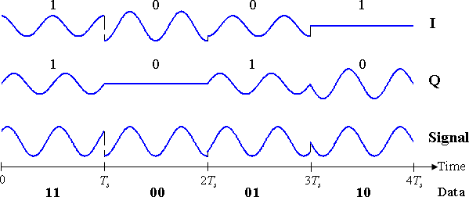

**Timing diagram for DQPSK**

In this diagram we see a random binary data stream of a modulated signal. This build is the same as an ordinary QPSK build. The sequential symbols here are taken from the sequential symbols in the DQPSK constellation diagram. Thus the first symbol (1 1) is taken from the constellation "blue" and the second symbol (0 0) is taken from the constellation "green". Note that the amplitudes of the bicomponent waves change as you switch between constellations, but the amplitude of the total signal remains constant (constant envelope). The phase shifts are between those of the two previous timing diagrams. Here we see the binary data stream below the time axis in the timing diagram for π/4-QPSK. The two signal components with their bit assignments are shown at the top and the total combined signal at the bottom. Note that the consecutive symbols are taken alternately from the two constellations, starting with the "blue" one.

### Demodulation

For a signal that has been differentially encoded, there is an obvious alternative method of demodulation. Instead of demodulating as usual and ignoring carrier-phase ambiguity, the phase between two successive received symbols is compared and used to determine what the data must have been. When differential encoding is used in this manner, the scheme is known as differential phase-shift keying (DPSK). Note that this is subtly different from just differentially encoded PSK since, upon reception, the received symbols are not decoded one-by-one to constellation points but are instead compared directly to one another.

**QPSK and DQPSK Constellations**

Constellation diagrams are graphical representations of possible points a signal can take in the complex plane. They are often used to visualize and analyze the behavior of digital modulation schemes such as quaternary amplitude modulation (QAM), phase shift keying (PSK), and frequency shift keying (FSK). In a constellation diagram, points in the complex plane correspond to different symbols that can be transmitted by the modulation diagram. The distance between dots represents the signal-to-noise ratio (SNR) of the transmission, and smaller distances correspond to higher SNR. Constellation diagrams can be used to visualize the performance of a digital modulation scheme under different channel conditions such as varying SNR or interference. They can also be used to design and optimize the modulation scheme for a particular application or communication system. Overall, constellation diagrams are a useful tool for understanding and analyzing the behavior of digital modulation schemes and can help designers and engineers optimize the performance of communication systems.

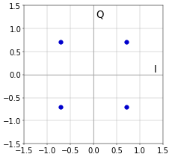

**QPSK constellation**

In a constellation diagram, the complex plane is divided into a grid, and each point on the grid represents a symbol that can be communicated by the modulation diagram. The distance between points in the constellation diagram represents the signal-to-noise ratio (SNR) of the transmission. By analyzing the constellation diagram, it is possible to understand how the modulation scheme performs under different channel conditions. For example, if the SNR is low, the points in the constellation diagram may be closer together, indicating that the symbols are more difficult to distinguish. On the other hand, if the SNR is high, the points in the constellation diagram will be farther apart, indicating that the symbols are easier to distinguish. Constellation diagrams can also be used to optimize the performance of a communication system. For example, if the SNR of a transmission is too low, a different modulation scheme with larger distances between points in the constellation diagram can be used to improve the performance of the system. Overall, constellation diagrams are a useful tool for understanding and analyzing the behavior of digital modulation schemes and can help designers and engineers optimize the performance of communication systems.

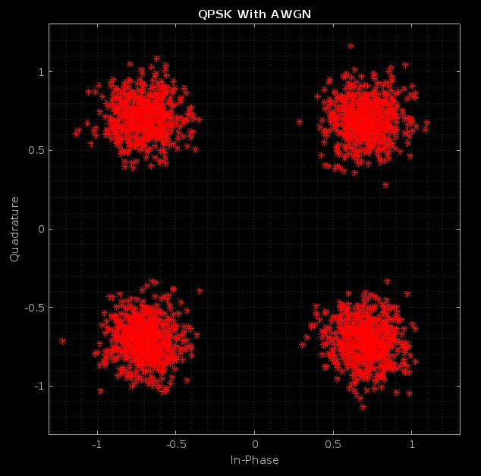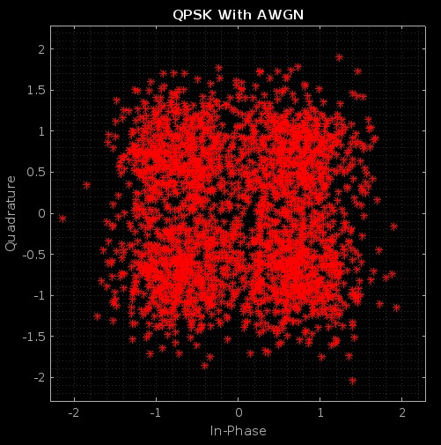

**QPSK SNR of 15 dB QPSK SNR of 5 dB**

If we briefly summarize the diagrams, we observe the distribution of the stars in the constellation diagrams in the symbol space of the SNR value in dB in the range of 5-15 dB. At 15 dB SNR, the symbols are positioned very close to each other. This is because the strength of the noise does not outweigh the strength of the signal. However, at 5 dB SNR, the power of the noise is greatly increased compared to the power of the signal. This means that the rate of being affected by noise will increase for the symbol representing each bit pair sent. For this reason, at 5dB SNR, the symbols are fringed in the symbol space.

Quadruple Phase Shift Keying (QPSK) is a digital modulation scheme that transmits information by changing the phase of a carrier signal. It encodes two bits of data per symbol, allowing a higher data rate than simpler schemes such as Binary Phase Shift Keying (BPSK). In QPSK, the phase of the carrier signal is changed in 90 degree increments. There are four possible phase shifts: 0 degrees, 90 degrees, 180 degrees and 270 degrees. These phase shifts correspond to four possible combinations of symbols: 00, 01, 10, and 11. Symbols are represented in a constellation diagram, with each symbol represented by a dot on the diagram. For example, consider a QPSK signal with a carrier frequency of 1 Hz and a symbol rate of 1 symbol per second. The first symbol transmitted can be 00, which corresponds to a phase shift of 0 degrees. The second symbol could be 01, which corresponds to a phase shift of 90 degrees. The third symbol could be 10, corresponding to a 180 degree phase shift, and so on. QPSK is widely used in wireless communication systems such as cellular networks and satellite communications because of its ability to transmit data at high speeds with relatively low error rates. It is also used in other communication systems such as cable modems and digital audio broadcasting.

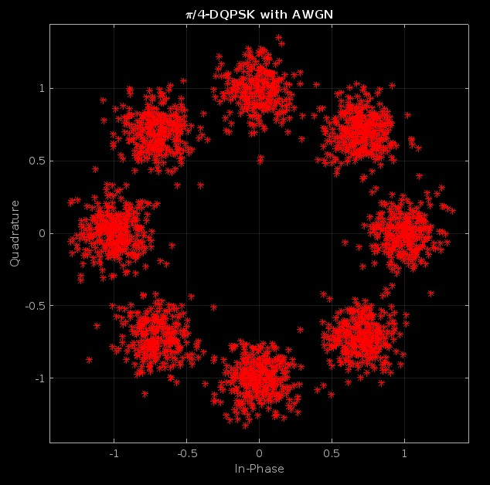

**π/4-DQPSK SNR of 15 dB**

Differential Quadruple Phase Shift Keying (DQPSK) is a variation of the Quadruple Phase Shift Keying (QPSK) digital modulation scheme. It is similar to QPSK in that it encodes two bits of data per symbol and uses phase shifts of 0, 90, 180, and 270 degrees to represent four possible symbol combinations. However, in DQPSK, the phase shift of each symbol is determined by the phase shift of the previous symbol. Specifically, the phase shift of each symbol is equal to the difference between the phase shifts of the previous and current symbols. This allows the receiver to determine the phase shifts of symbols based on the phase shifts of the previous symbols without needing a reference signal. Like QPSK, DQPSK is widely used in wireless communication systems due to its ability to transmit data at high speeds with relatively low error rates. It is especially useful when the signal-to-noise ratio is low, as it is more noise-tolerant than QPSK. In the constellation diagram, the symbols in the DQPSK signal are represented by dots on the diagram, just as in the QPSK. However, the dots are combined with lines to indicate the relationship between the phase shifts of the symbols. The lines in the diagram form a spiral pattern, with each dot representing a symbol and each line representing the phase shift between two consecutive symbols.

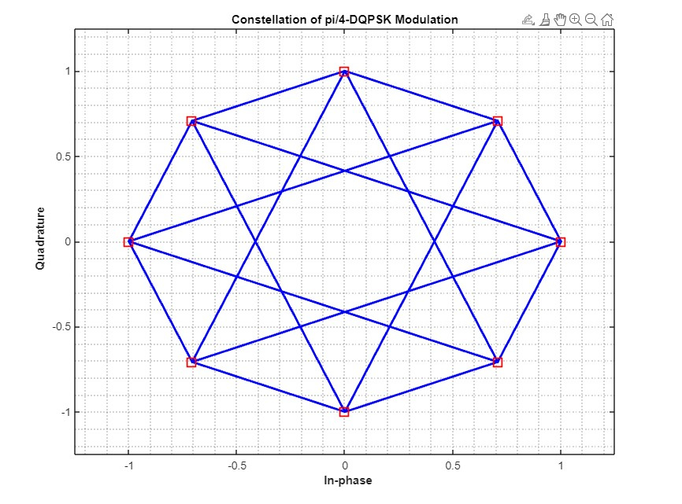

**Spiral Modeling of Phase Shifts**

**QPSK and DQPSK BER ANALYSIS**

Several parameters can be used to analyze the performance of a QPSK system, including: bit error rate (BER) and symbol error rate (SER). BER is a measure of the number of errors in transmitted data, expressed as a fraction of the total number of bits transmitted. Other parameters that can be used to analyze the performance of a QPSK system include signal-to-noise ratio (SNR), signal to interference ratio (SIR), and signal to noise and interference ratio (SNR). These parameters are used to evaluate the quality of the received signal and can be used to optimize the performance of the QPSK system. In general, the analysis of QPSK systems involves evaluating the performance of the system under different conditions, such as different noise and interference levels, to optimize the system design and ensure reliable data transmission.

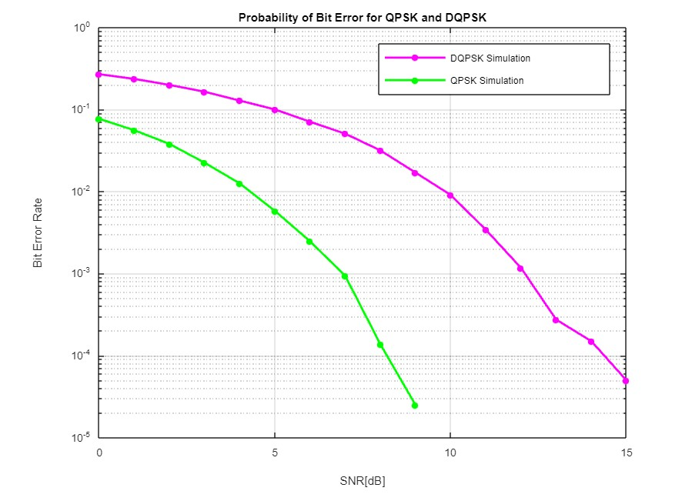

**BER and SNR Analysis and Effects**

One advantage of QPSK is that it is relatively robust against noise and interference when compared to other types of phase shift keying (PSK) modulation. This is because QPSK uses four different phase shifts that allow it to transmit more data per symbol and therefore achieve a higher data rate.

The BER values of a QPSK system can be calculated using analytical models or simulated using computer models. These models take into account various factors that can affect the performance of the system, such as signal-to-noise ratio (SNR), signal-to-interference ratio (SIR), and signal-to-noise-and-.

SNR is a measure of the strength of the received signal relative to the noise present in the system. A higher SNR means the signal is stronger relative to noise, which can result in a lower BER.

DQPSK (Differential Quadruple Phase Shift Keying) is a type of digital modulation similar to QPSK (Quad Phase Shift Keying) but uses differential coding to improve system performance. In DQPSK, the phase of the carrier signal changes according to the transmitted digital data, but the phase shifts are not directly encoded. Instead, phase shifts are determined by comparing the current symbol with the previous symbol, allowing the receiver to detect and correct any errors that may occur during transmission. Various parameters, including bit error rate (BER) and symbol error rate (SER), can be used to analyze the performance of a DQPSK system. BER is a measure of the number of errors in transmitted data, expressed as a fraction of the total number of bits transmitted. SER is a measure of the number of errors in transmitted symbols, expressed as a fraction of the total number of symbols transmitted.

One advantage of DQPSK is that it is more resistant to errors from noise and interference than QPSK. This is because DQPSK uses differential coding, which allows the receiver to detect and correct any errors that may occur during transmission. Quadrature Phase Shift Keying (QPSK) and Differential Quadrature Phase Shift Keying (DQPSK) are two types of digital modulation techniques used in communication systems. Both techniques are used to transmit digital data over a wireless or wired channel by modulating a carrier signal. In QPSK, the phase of the carrier signal is shifted in four different states to represent two bits of data. For example, if the carrier signal is a sinusoidal wave, the phase of the wave can be 0 degrees, 90 degrees, 180 degrees, or 270 degrees to represent the four possible states. In DQPSK, the phase of the carrier signal is shifted in two different states to represent one bit of data, and the phase shift is determined by the previous bit.

Both QPSK and DQPSK have similar bit error rates (BERs), but DQPSK has a slightly lower BER compared to QPSK. This is because DQPSK uses differential encoding, which means that the phase shift of the carrier signal is determined by the previous bit, rather than the current bit as in QPSK. This makes it more resistant to noise and interference, which can cause errors in the transmitted data. However, DQPSK requires more complex hardware and processing to implement, compared to QPSK. This makes it more expensive and less practical to use in some applications. In summary, QPSK and DQPSK have similar BERs, with DQPSK having a slightly lower BER due to its differential encoding. However, DQPSK requires more complex hardware and processing to implement, which may make it less practical for some applications.

**Differences, Advantages and Usage Areas of QPSK and DQPSK**

QPSK(Quadrature Phase Shift Keying) and DQPSK(Differential Quadrature Phase Shift Keying) modulation techniques are modulation techniques used in digital data transfer. These techniques transmit data by modulating it to a carrier signal. However, there are important differences between these two techniques, and in the final report of this project, we would rather focus on and explain the differences, advantages and usage areas of these two modulation schemes.

Data Rate: QPSK modulation has a lower data rate than DQPSK modulation. Therefore, QPSK modulation is more suitable for applications that require low data rates.

Signal-to-noise ratio: QPSK modulation has a higher signal-to-noise ratio than DQPSK modulation. Therefore, QPSK modulation performs better in low noise environments.

Error correction: DQPSK modulation has better error correction ability than QPSK modulation. Therefore, DQPSK modulation is more suitable for applications that require error correction.

Modulation technique: QPSK modulation takes data bits in pairs and applies a phase change for each group separately. DQPSK modulation, on the other hand, takes data bits one by one and applies a phase change from the previous data bit. Therefore, DQPSK modulation requires less data rate.

In general, QPSK modulation is better suited for low data rate applications and performs better in low noise environments. DQPSK modulation, on the other hand, is more suitable for applications that require error correction and requires less data rate.

QPSK (Quadrature Phase Shift Keying) modulation takes data bits in pairs and applies a phase shift for each group separately. For example, if the data bits are considered as 00, 01, 10, and 11, then QPSK modulation takes these data bits in pairs and applies a phase change according to the data bits in each group. Therefore, QPSK modulation uses two different phase changes relative to the data bits. DQPSK (Differential Quadrature Phase Shift Keying) modulation takes the data bits one by one and applies a phase shift relative to the previous data bit. For example, if the data bits are considered as 0101, DQPSK modulation takes these data bits one by one and applies a phase change relative to the previous data bit. Therefore, DQPSK modulation does not apply a phase change for each data bit, but a phase change with respect to the previous data bit.

QPSK modulation is more suitable for low data rate applications and performs better in low noise environments. This may be because QPSK modulation applies a phase change to individual data bits. DQPSK modulation, on the other hand, is more suitable for applications that require error correction and requires less data rate. It. It may be due to the DQPSK modulation applying a phase change relative to the previous data bit.

**Applications**

They are commonly used in communication systems, including cellular networks, satellite systems, and other wireless communication systems.

QPSK is used in a variety of applications, including:

Digital television and radio broadcasting

Wireless local area networks (WLANs)

Digital subscriber line (DSL)

Global positioning systems (GPS)

Digital audio broadcasting (DAB)

DQPSK is also used in a variety of applications, including:

Cellular networks, including GSM and 3G

Satellite systems

Wireless local area networks (WLANs)

Digital subscriber line (DSL)

Global positioning systems (GPS)

Both QPSK and DQPSK are widely used because they offer a good balance between spectral efficiency and robustness against noise and interference. They are also relatively easy to implement and can be used in a variety of frequency bands and transmission environments.